# Exp No: 3 Date: 07/08/2024

**VIRTUALIZATION**

# INSTALLATION OF VIRTUAL MACHINE IN VIRTUAL BOX

**AIM:**

To configure a Virtual Machine using Virtual Box and Launch to execute a simple program using PYTHON.

# PROCEDURE:

1. Launch a Virtual Box
2. Create new virtual machine
3. Customize the set-up
4. Set username and password
5. Browse for .iso file of an operating system
6. Configure the hardware capacity
7. Finish and power on the VM
8. Install C or PYTHON OR JAVA Compiler and execute a simple program

# OUTPUT:

The virtual machine of Ubuntu OS was created using a virtual box. Ubuntu virtual machine running in Virtual Box.

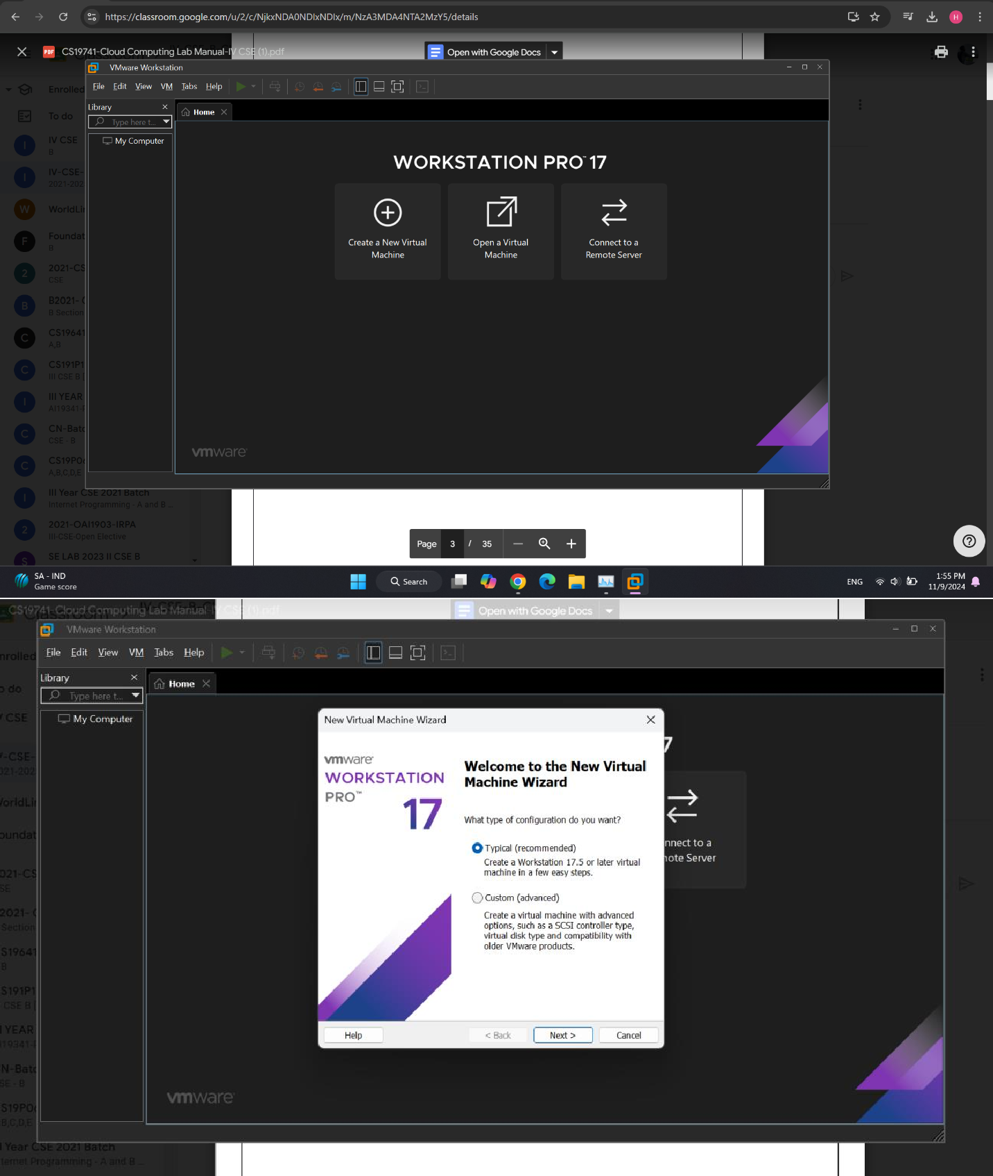

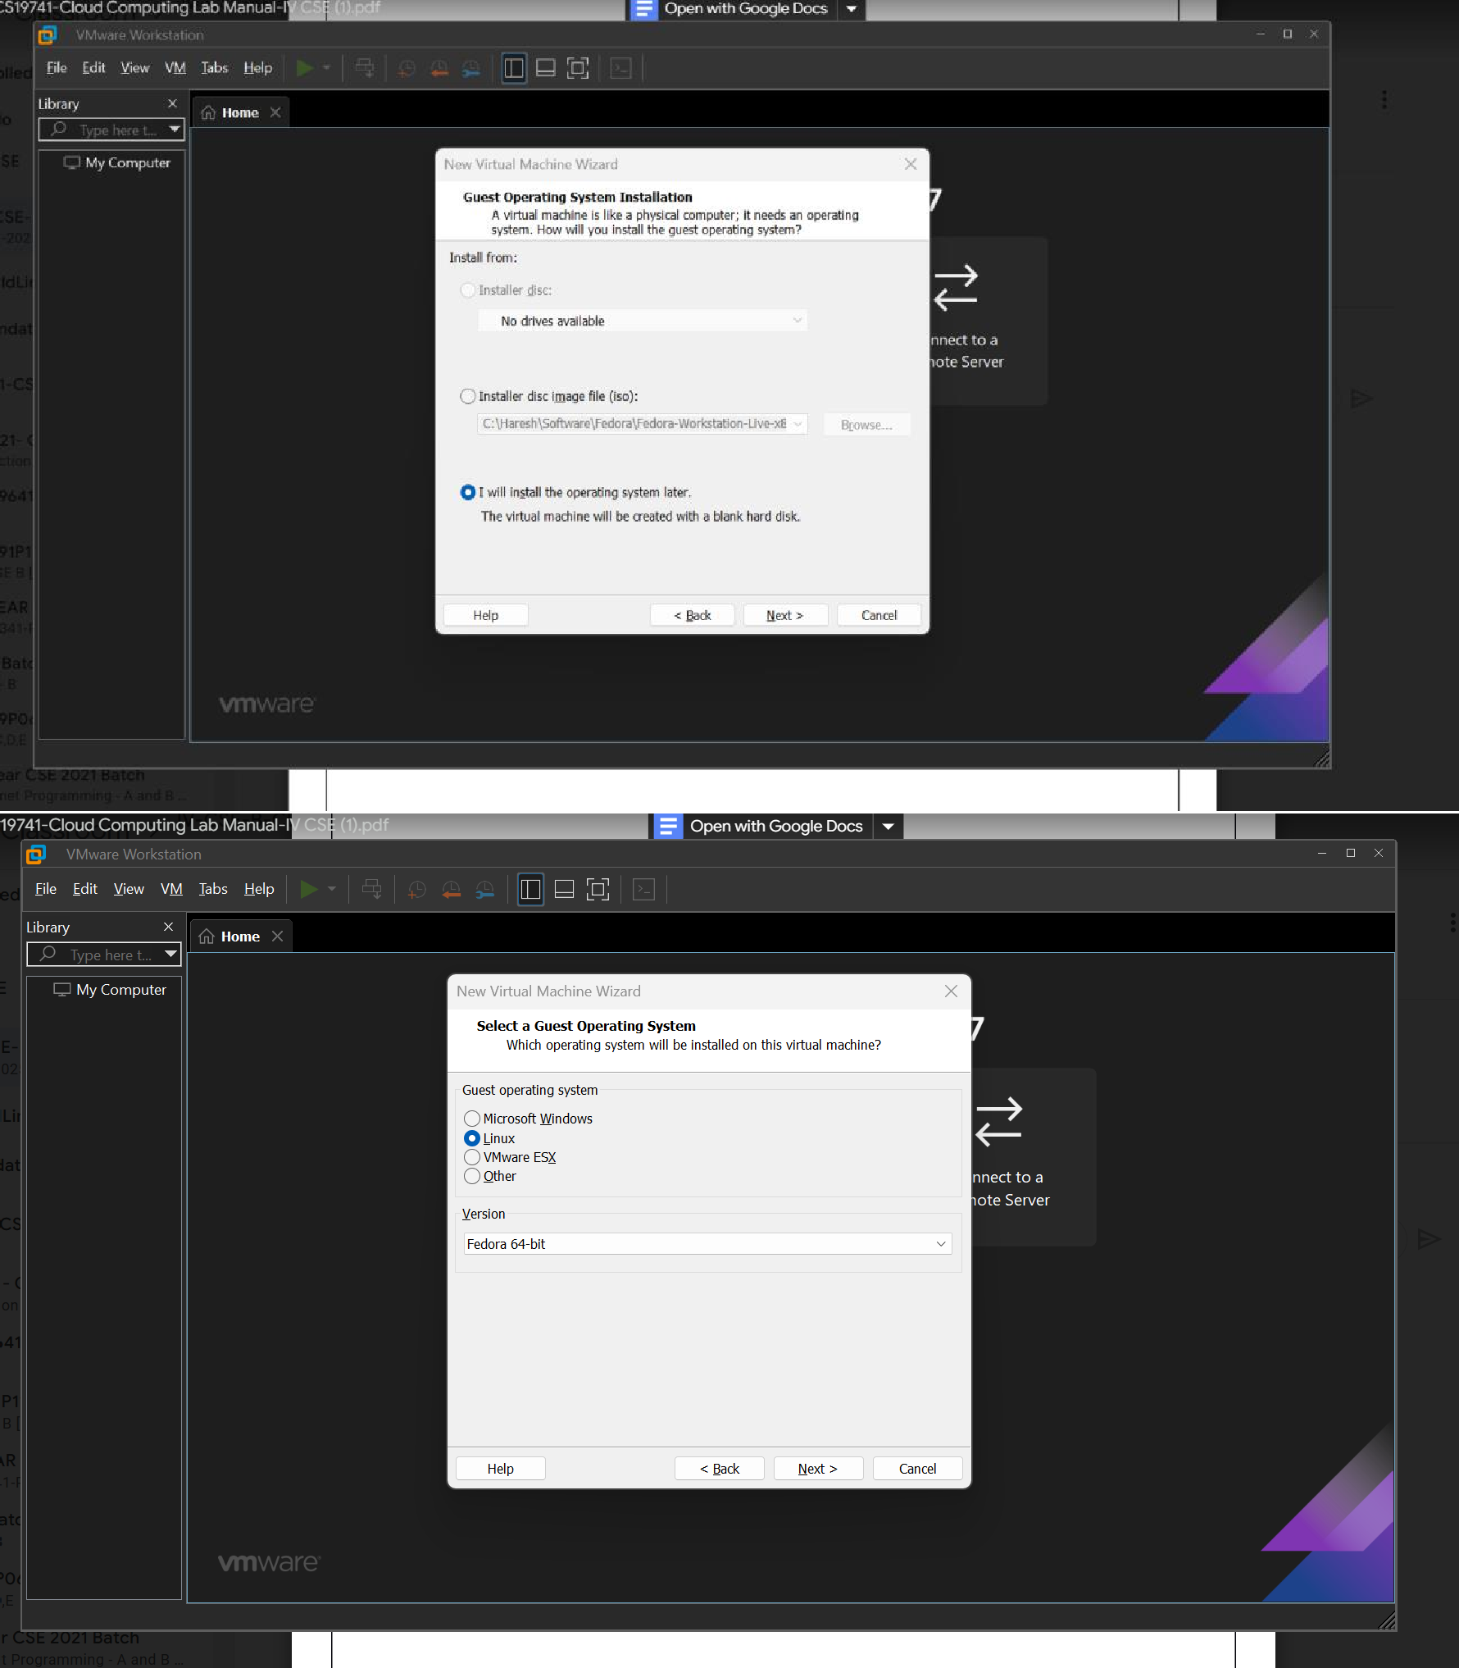

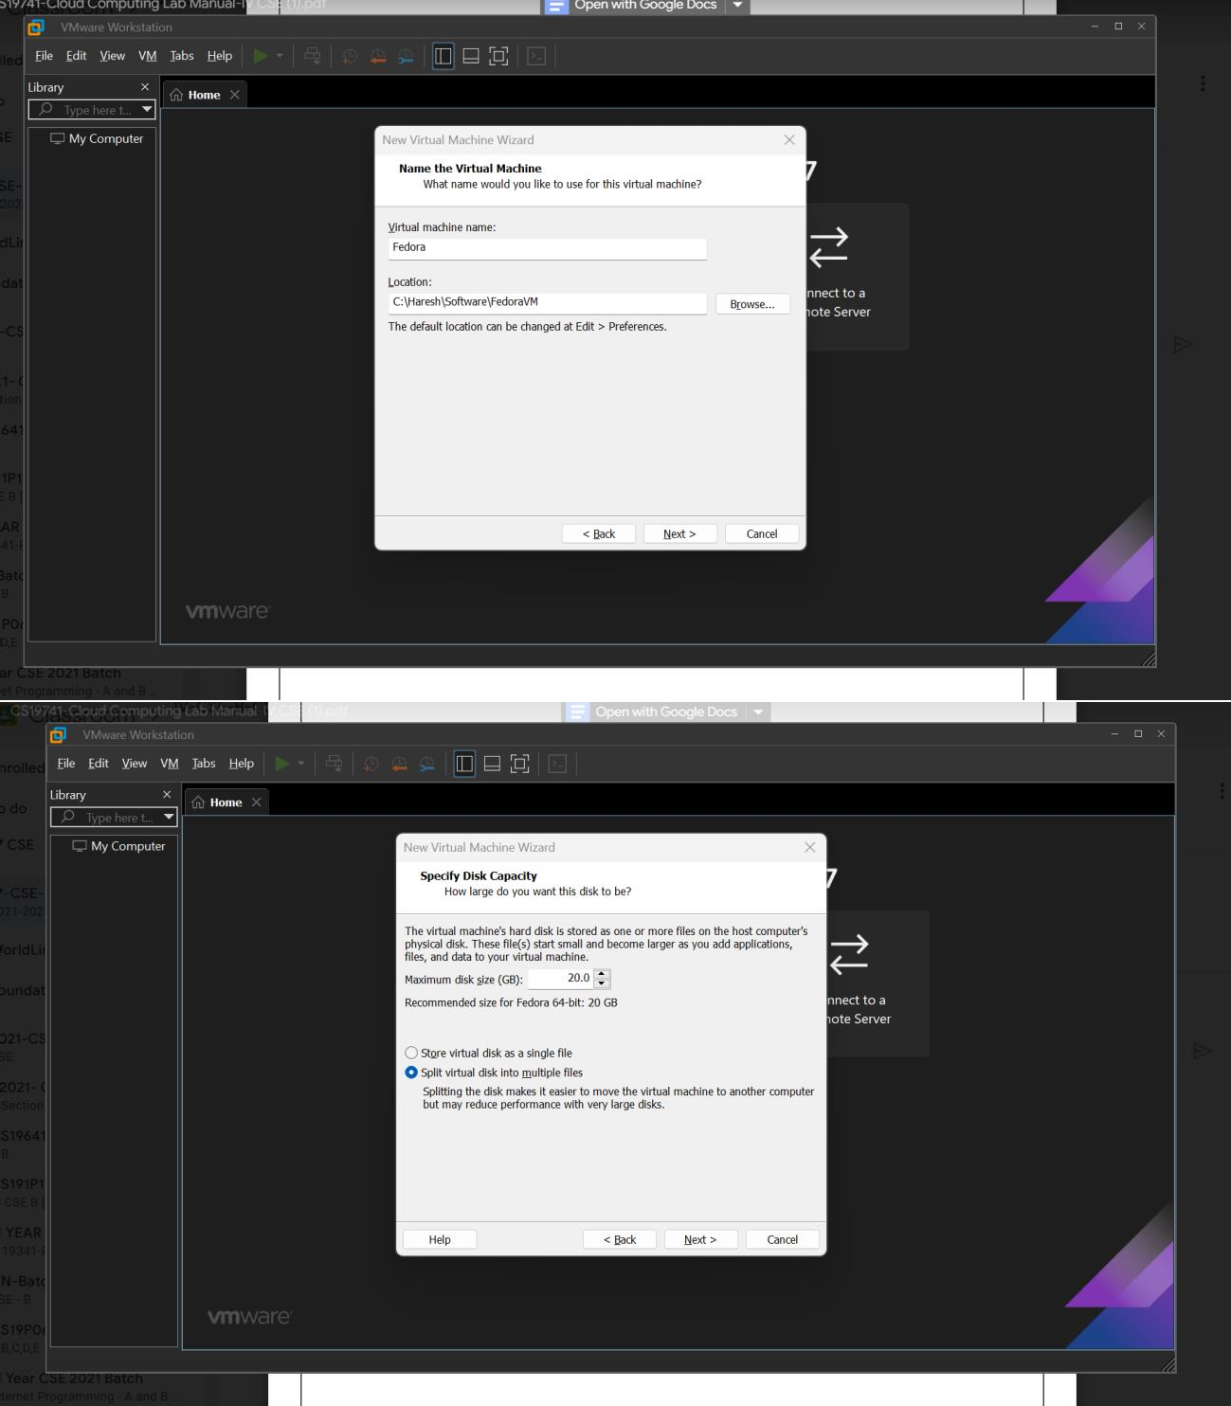

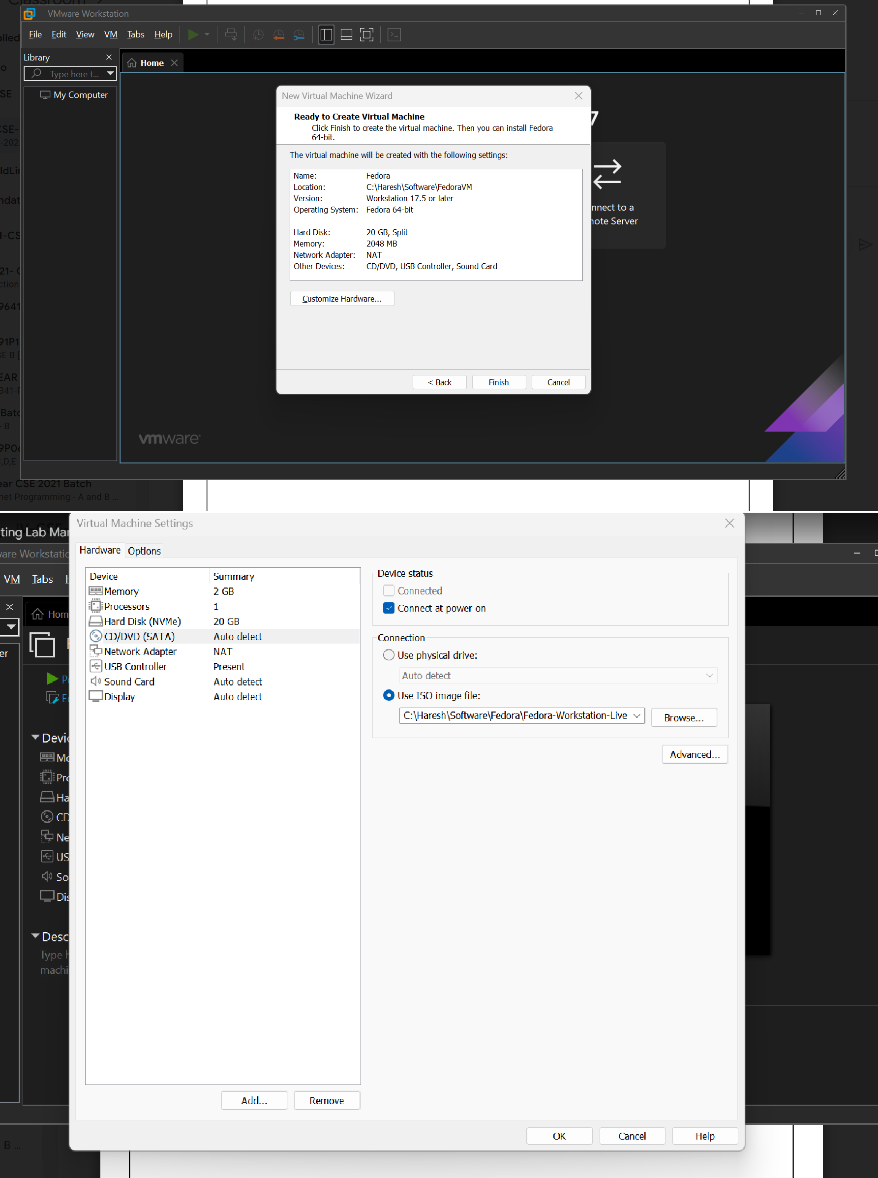

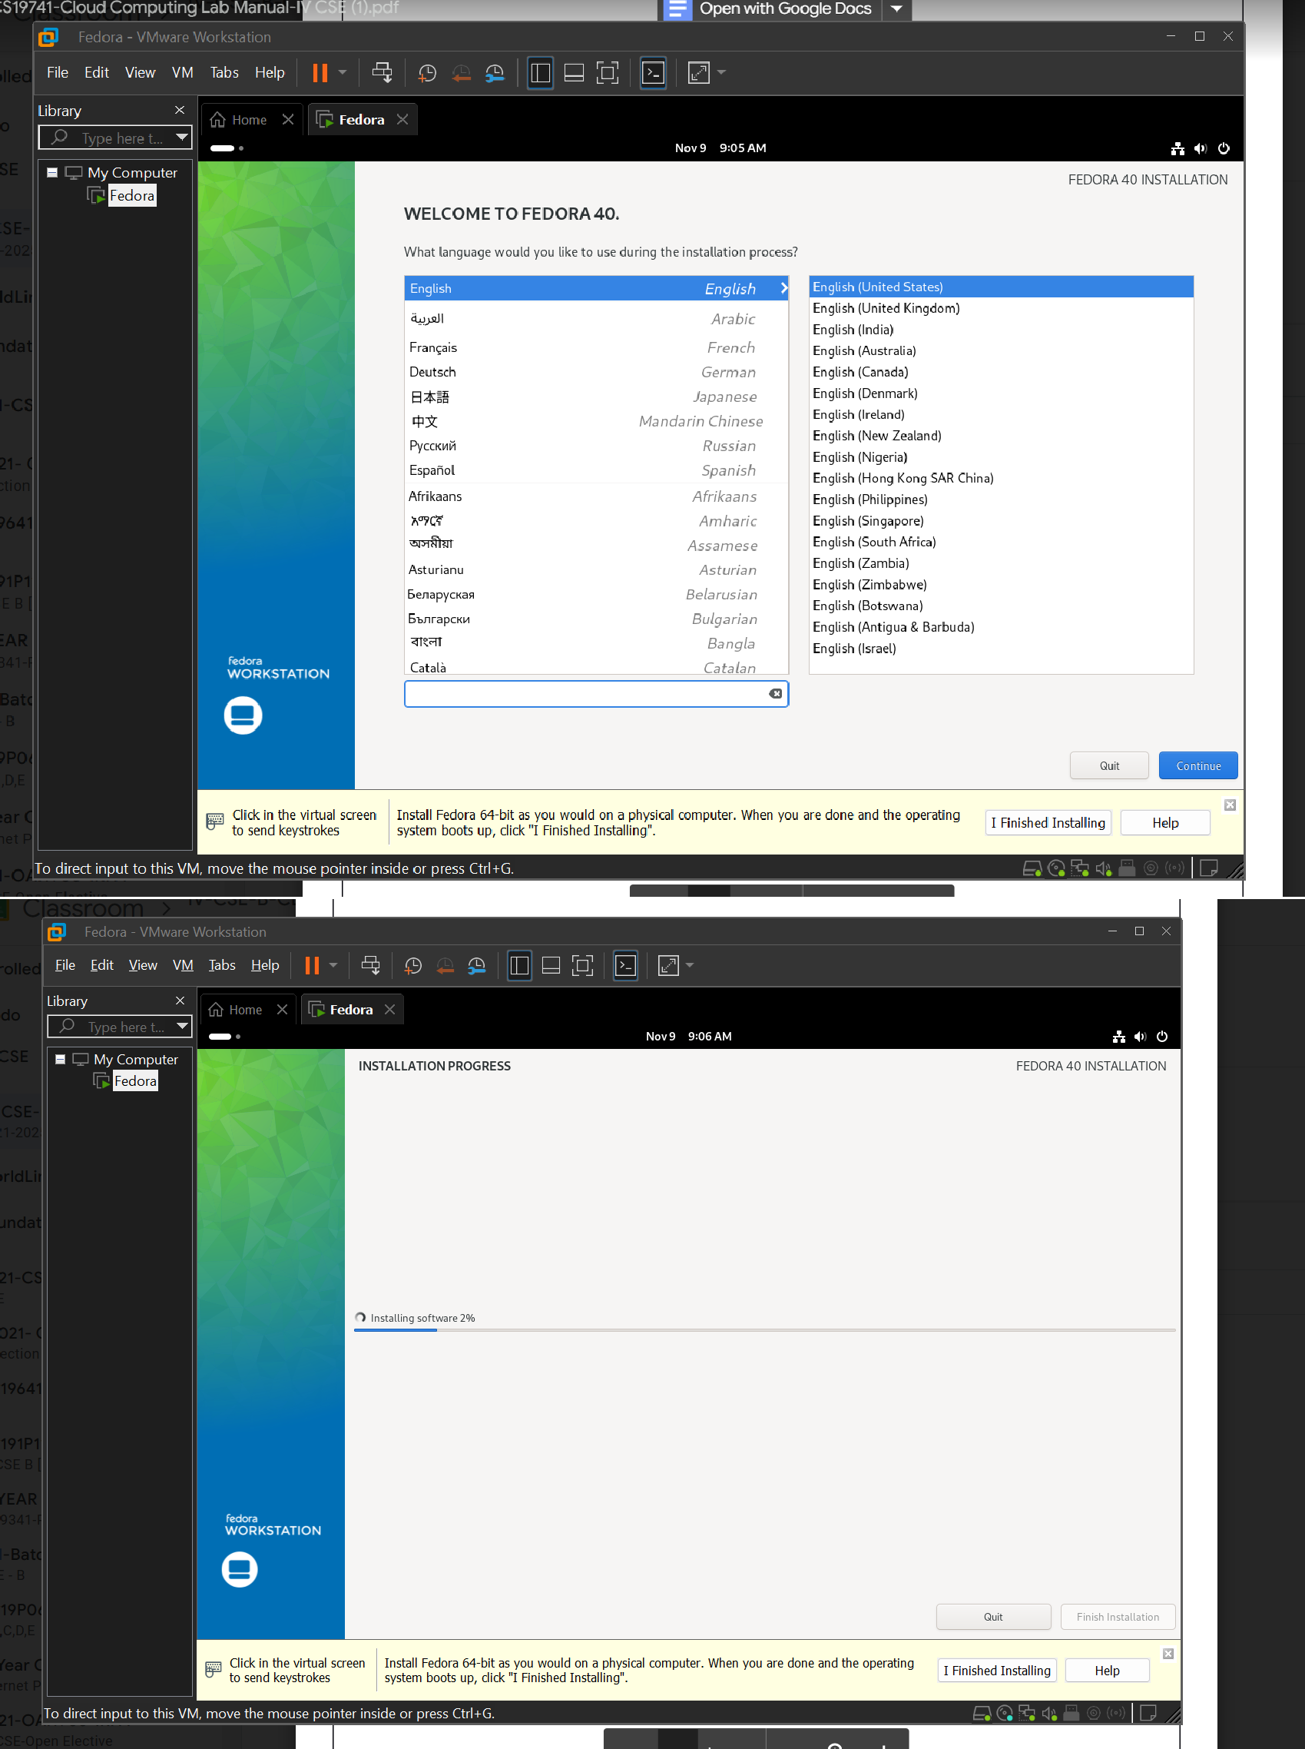

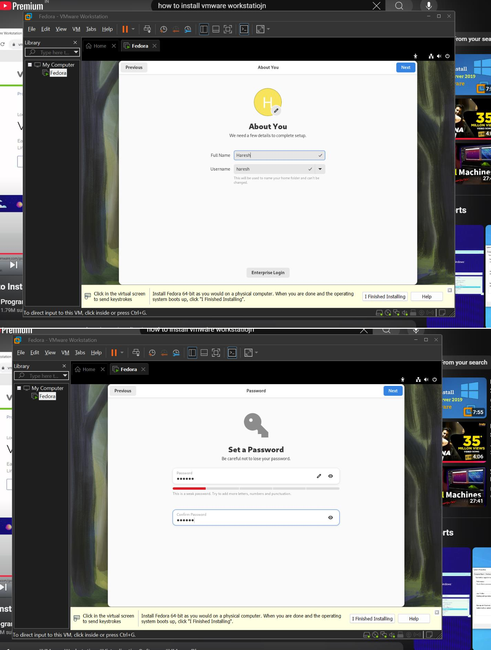

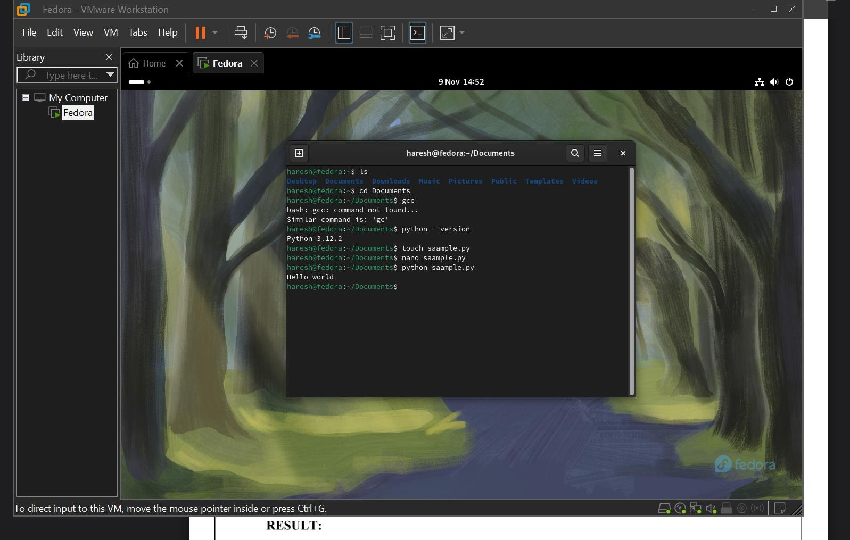

# RESULT:

A Virtual Machine using Virtual Box is created and executed a simple program using PYTHON.